Improve the cross-sectional area of conductors and the power factor of the grid
Using renewable energy is an effective way to reduce carbon footprint. However, because of the fluctuating characteristics of wind and solar power (Chen et al., 2020), reducing the carbon footprint through grid modification is also an idea.

The transmission of electricity in the power system is achieved through the burning of fossil fuels and nuclear energy processes to generate a large amount of electricity, and then the transmission of electricity to the user over a long distance, which will generate a large amount of carbon emissions (Karimi-Ghartemani, 2022).

In the University of Glasgow, all kinds of teaching activities and experimental research are inseparable from the consumption of electric energy, resulting in a large amount of carbon dioxide emissions. Therefore, to reduce the carbon emissions of the university can be achieved by reducing the consumption of electric energy.

In the transmission process of electric energy, there will be losses in various links such as power transmission and transformation in the power grid (Wu & Ni, 2016). Some losses are inevitable, but some losses can be reduced by improving the power grid. When the cross-sectional area of the grid wire is set unreasonable, the loss of the circuit will become larger, so the most appropriate wire diameter should be determined by the load of electricity. Each building of the school needs different electricity consumption, so in order to make the power grid operate in a more economical state, the wire of different diameters is determined according to the electricity load of different buildings.

Figure 1
Half hourly electricity data for the main HV incomers to the Gilmore hill site
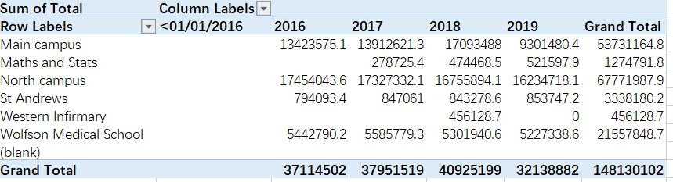
Note. From the Energy Team at the university of Glasgow.

As can be seen from Figure 1, different buildings on campus have different demands for electric energy. For buildings with large electricity consumption, such as the main campus and the north campus, the required wires have high requirements for carrying current. Therefore, the wires with large cross-sectional area are selected, while the wires with small wire diameter can be connected to buildings with less electricity load.

In order for the University of Glasgow to carry out various activities normally, the active power required by the campus grid is limited. Therefore, the operation efficiency of the grid can be improved by reducing unnecessary reactive power (Ciucur et al., 2016). In other words, the natural power factor of the grid can be properly improved. On the other hand, manual compensation can also be performed to improve the power factor. For example, install some reactive power compensation equipment, such as the installation of shunt capacitors in the grid.
Advantages
At the University of Glasgow, electricity consumption accounts for a large proportion of carbon emissions, so improving the power grid to operate in a more energy-efficient state is an effective way to reduce the carbon footprint.
It does require material resources and manpower to re-design and lay the wires of the power grid. However, in the long run, the new wires can not only reduce the risk of impedance increase caused by line aging, but also avoid more safety problems such as electric leakage while reducing the loss. As a result, maintenance costs are reduced.

The reconstruction of the power grid of the University of Glasgow can reduce the line loss rate of the power grid, effectively reduce the electrical energy loss of the university, improve the efficiency of electric energy use, thus reducing the energy consumption of the university and reducing environmental pollution.
The re-laying of grid wires and adding reactive compensation devices to reduce power loss can be maintained for a long time, and the maintenance cost is low.

References
Chen, Y., Koduvere, H., Gunkel, P. A., Kirkerud, J. G., Skytte, K., Ravn, H., & Bolkesjø, T. F. (2020). The role of cross-border power transmission in a renewable-rich power system – A model analysis for northwestern europe. Journal of Environmental Management, 261, 110194-110194. https://doi.org/10.1016/j.jenvman.2020.110194
Ciucur, V., Dordescu, M., & Nedelcu, E. (2016). Natural ways to improve the power factor. Paper presented at the , 10010 100102R-100102R-6. https://doi.org/10.1117/12.2245835
Karimi-Ghartemani, M. (2022). Modeling and control of modern electrical energy systems. John Wiley & Sons, Inc.
Wu, A., & Ni, B. (2016). Line loss analysis and calculation of electric power systems. Wiley. https://doi.org/10.1002/9781118867273

